30.07.2020

**Lab-III-HTML Semantics and basic CSS**

1.

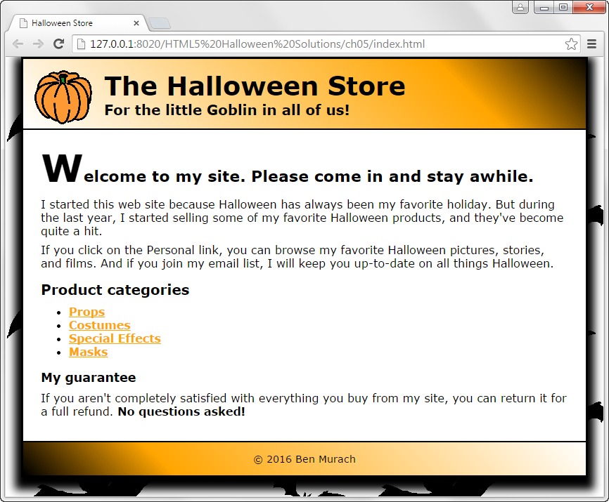

2. Design the page linked as "[**Page_to_design**](../assn4.jpg)**" based on the given** [**Layout**](../pageForm.jpg)**.**

**Requirements:** [**content and images**](e:\Admin\Downloads\kauai.zip)

